Musee Des Beaux Arts

About suffering they were never wrong,
The Old Masters: how well they understood
Its human position; how it takes place
While someone else is eating or opening a window or just
walking dully along;
How, when the aged are reverently, passionately waiting
For the miraculous birth, there always must be
Children who did not specially want it to happen, skating
On a pond at the edge of a wood:
They never forgot
That even the dreadful martyrdom must run its course
Anyhow in a corner, some untidy spot
Where the dogs go on with their doggy life and the
torturer’s horse
Scratches its innocent behind on a tree.

In Brueghel’s Icarus, for instance: how everything turns away
Quite leisurely from the disaster; the ploughman may
Have heard the splash, the forsaken cry,
But for him it was not an important failure; the sun shone
As it had to on the white legs disappearing into the green
Water; and the expensive delicate ship that must have seen
Something amazing, a boy falling out of the sky,
Had somewhere to get to and sailed calmly on.
W. H. Auden (1907-1973)

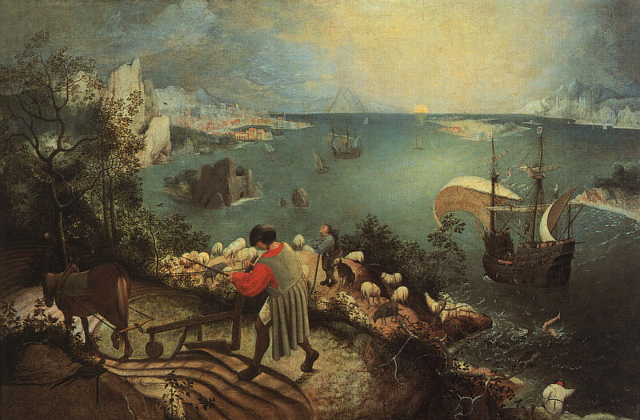

The Road Not Taken

Two roads diverged in a yellow wood,
And sorry I could not travel both
And be one traveler, long I stood
And looked down one as far as I could
To where it bent in the undergrowth;

Then took the other, as just as fair,
And having perhaps the better claim,
Because it was grassy and wanted wear;
Though as for that the passing there
Had worn them really about the same,

And both that morning equally lay
In leaves no step had trodden black
Oh, I kept the first for another day!
Yet knowing how way leads on to way.
I doubted if I should ever come back.

I shall be telling this with a sigh
Somewhere ages and ages hence:
Two roads diverged in a wood, and I—
I took the one less traveled by,
And that has made all the difference.

Robert Frost 1915, 1916

