What is this machine?

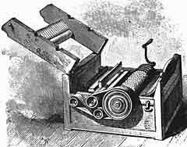

Who is this man?

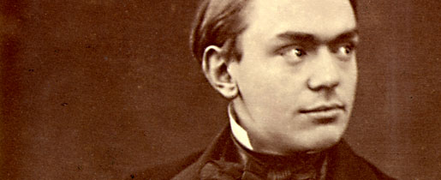
Hints: Swedish—combined chalk-like sedimentary rock with a mystery ingredient

How about this guy?

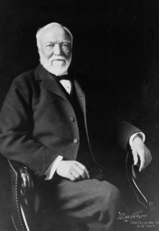
Hint: Was at one time worth US$1,400,000,000—4% of U.S. national wealth at the time)
Gave away $350,695,653 before he died.

What does this graph depict?

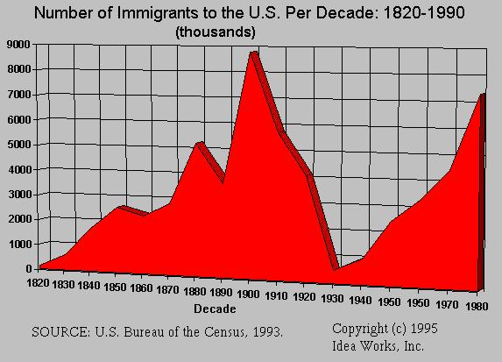

Which war went by the following names?

The War to End All Wars
The War to Make the World Safe for Democracy
The War of the Nations

What were these men preparing?
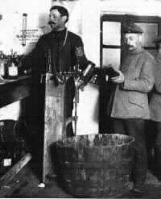

Hint: a kind of weapon

Where would you find the following?

"Give me your tired, your poor,
Your huddled masses yearning to breathe free,
The wretched refuse of your teeming shore.
Send these, the homeless, tempest-tossed to me.
I lift my lamp beside the golden door."

What is this?



Hint: in New York on an island.

What is the following an example of?

Name of Passenger |  | Residence |  | Arrived |  | Age on Arrival | Passenger Record | Ship Manifest | Ship Image
1. | Otto Roth |  |  |  | 1895 | 20 | View | View | View
2. | Otto Roth |  |  |  | 1908 | 30 | View | View | View
3. | Otto Roth |  |  |  | 1906 | 32 | View | View | View
4. | Otto Roth |  |  |  | 1923 | 37 | View | View | View
5. | Otto Roth |  |  |  | 1911 | 38 | View | View | View
6. | Otto Roth |  | Brooklyn, U.S.A. |  | 1918 | 37 | View | View | View
7. | Otto Roth |  | Brooklyn, U.S.A. |  | 1921 | 41 | View | View | View
8. | Otto Roth |  | Chicago, Illinois |  | 1924 | 45 | View | View | View
9. | Otto Roth |  | Elmshorn |  | 1903 | 16 | View | View | View
10. | Otto Roth |  | Idar, Germany |  | 1914 | 29 | View | View | View
11. | Otto Roth |  | Mondfeld, Germany |  | 1909 | 24 | View | View | View
12. | Otto Roth |  | Olsnik |  | 1905 | 31 | View | View | View
13. | Otto Roth |  | Schonebeck, Germany |  | 1922 | 45 | View | View | View
14. | Otto Roth |  | Switzer, Dnrish |  | 1909 | 28 | View | View | View
15. | Otto Roth |  | Switzerland |  | 1910 | 29 | View | View | View
16. | Otto Roth |  | Uster, Switzerland |  | 1912 | 32 | View | View | View
17. | Otto A. Roth |  | Chicago, Ill. |  | 1922 | 43 | View | View | View
18. | Otto A. Roth |  | Chicago, Ill. |  | 1924 | 45 | View | View | View

Whom does the following describe?

In October 1913, this 71 year old man departed Washington on a tour to revisit his old Civil War battlefields. By December, he had proceeded on through Louisiana and Texas, crossing by way of El Paso into Mexico, which was then in the throes of revolution. In Ciudad Juárez, he joined the army of Pancho Villa as an observer, in which role he participated in the battle of Tierra Blanca. He is known to have accompanied Villa's army as far as the city of Chihuahua, Chihuahua. After a last letter to a close friend, sent from that city on December 26, 1913, he vanished without a trace, becoming one of the most famous disappearances in American literary history. Subsequent investigations to ascertain his fate were fruitless; despite many decades of speculation, his disappearance remains a mystery, and his (unconfirmed) date of death is generally listed as "1914?".
In one of his last letters, he wrote:
"Good-by — if you hear of my being stood up against a Mexican stone wall and shot to rags please know that I think that a pretty good way to depart this life. It beats old age, disease, or falling down the cellar stairs. To be a Gringo in Mexico — ah, that is euthanasia".

- Abraham Lincoln
- Ambrose Bierce
- William McKinley
- Teddy Roosevelt

Girls born before 1860 spent their childhood and adolescence learning what skill?

According to Godey's Lady's Book, before this invention, it took about 14 hours to make a man's dress shirt and at least 10 hours for a simple dress.
With this invention, those hours dropped to one and a quarter hours for the shirt and one hour for the simple dress.

A Historical Look at U.S. Immigration Policy

Girls born before 1860 spent their childhood and adolescence learning to sew a fine seam. Once the machine was available workmanship steadily declined.

