Math 99-BN Review Activity Satake

Name:________________________
Read all directions and problems carefully! Show all appropriate work for credit.
1. Simplify the following using the laws of exponents.

2. Simplify each of the following. Leave answers in exponential form with positive exponents only.

3. Find the x- and y-intercepts of the line . Find three other solutions to the equation. Graph the line on the axes provided.
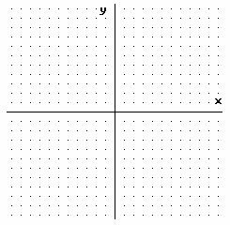

4. Graph the lines of the following equations on the axes provided and state the slope of each line.
5. Find the slope of the line containing each given pair of points.
; ; ;

6. Solve the following system (find the ordered pair) of linear equations in two variables by graphing.
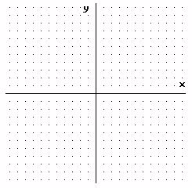
7. Solve the following system (find the ordered pair) of linear equations in two variables using the Elimination Method.

8. Solve the following system (find the ordered pair) of linear equations in two variables using the Substitution Method.

